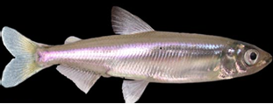
Workshop Date: Thursday May 18, 2017
Venue: Veterans Memorial Center, Davis CA
Time: 8:30 am-5:00 pm
Registration Fee: $20 (for refreshments and Lunch)
More details to come, please SAVE THE DATE!

What is the purpose of this Workshop?
As part of the Delta Smelt Resiliency Strategy, the California Department of Water Resources (DWR) is coordinating a multi-agency effort to examine if and how hatchery propagated Delta smelt could be utilized to aide in species recovery. Towards this goal DWR, DFW, USFWS, USBR and the American Fisheries Society CAL-NEVA Chapter have organized a workshop to bring agency experts, other technical experts, stakeholders, and other interested parties together to get an update on the status of wild Delta smelt, advances in Delta smelt propagation, the potential uses for hatchery Delta smelt, and to consider future management and monitoring issues. Outside experts from other successful recovery programs will provide their insights, guidance, and lessons learned to inform the discussion on the important next steps for the possible use of captive Delta smelt.

Why is this important?
- Species Management: Delta smelt may soon decline past the point where the wild population cannot recover without population supplementation actions such as reinforcement from a conservation hatchery population.
- Drought Effects: Delta smelt have declined precipitously during the recent drought.
- Proactive Approach: Although Delta smelt have not been extirpated from the wild, it is strategic to have an action plan in place for the worst-case scenario.
- Research: Evaluation of new monitoring techniques and enhancement activities may benefit from in-field, experimental use of hatchery produced Delta smelt.
What has been done so far to support hatchery production of Delta smelt?
- For over 25 years UC Davis has been funded by state and federal agencies to develop culture methods for Delta smelt.
- A refugial population of Delta smelt is maintained at the Fish Conservation and Culture Laboratory (UCD). A replicate of each generation is transported to and maintained at the Livingston Stone Hatchery (USFWS).
- USFWS and DWR are close to releasing an EIR/S for the development of a new Delta Fish Tech Center to support refugial populations of species including Delta smelt.
- USFWS and DWR are also working on a programmatic document for a full-scale conservation hatchery, but the original plan for this report did not include specifics about how hatchery-produced smelt might be used.
- Our situation is relatively unique because to our knowledge, only one other conservation hatchery program has been developed for annual fishes such as Delta smelt.

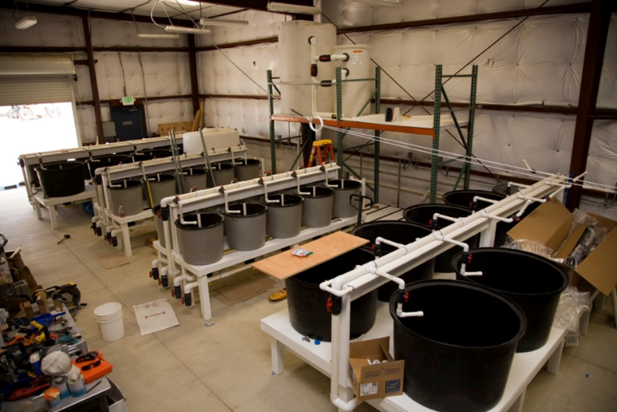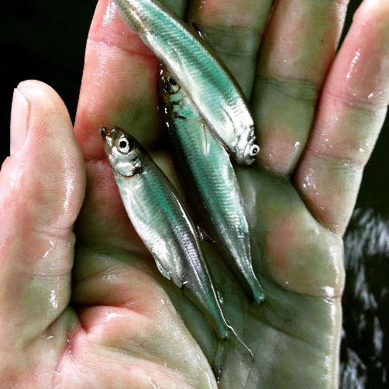

What types of questions would be addressed at the Workshop?
- What is the current status of wild Delta smelt?
- What progress is there in hatchery Delta smelt propagation?
- Under what circumstances should Delta smelt reinforcement be considered?
- How should Delta smelt population reinforcement actions be managed to maximize genetic diversity?
- What options are available to experimentally use or evaluate releases of hatchery produced Delta smelt?
- What life stages, habitats, and regions should potentially be targeted for reinforcement releases?
- If reinforcement releases occur, how should fish be released into the wild?
- What monitoring should accompany releases of hatchery Delta smelt to the wild?
- How should reinforcement efforts be adaptively managed to promote long term resiliency of wild Delta smelt?

