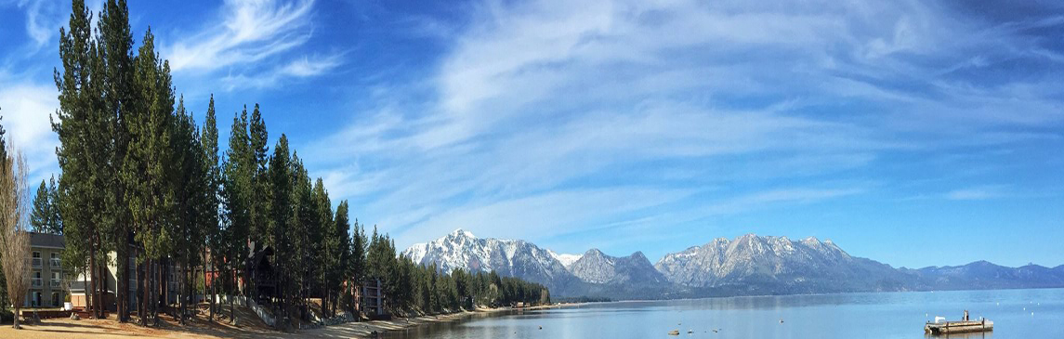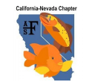
California-Nevada American Fisheries Society
First Annual Native Fishes Workshop

Thank you for your interest in attending the workshop. There is no cost for the workshop, but you must REGISTER TO ATTEND. There will be a camping charge for those wishing to stay either or both nights at Camp Richardson. We have a limit of 50 spots for the workshop/field tour, and 24 spots each night for camping. Camping spots have priority for workshop attendees. If you wish to bring family, we ask that you make an independent reservation at Camp Richardson, or make other lodging arrangements. No pets are allowed at Camp Richardson.

Please complete and email this form to Tom Taylor at aquathom@hotmail.com by Friday, 8/31/18.

Name (First & Last):
Phone Number:
Email Address:
Current Employer:
Number in Party:
Number Attending Workshop

Activities
Please indicate which activities you would like to attend by placing an ‘X’ in the blank next to the event. Attendees do not need to attend all activities. Please note the following:
--Post-presentation social and dinner on Friday, September 7.
-- All other meals are on your own
--Camping equipment is not provided for those staying at Camp Richardson. We have reserved two group campsites, each can accommodate 12 people and up to six tents. Cost of each group campsite will be shared equally by the parties using the site.
--Please bring snorkel gear and a wetsuit if you would like to look for native fishes during the field site visits.
Friday (9/7/18)
_______ Workshop Presentations
-Time: 2PM - 5PM
-Location: Camp Richardson Boat House (directions will be provided)

_______ Social and BBQ Dinner
-Time: 6PM
-Location: Taylor Cabin at Fallen Leaf Lake (directions will be provided)
- Cost – sponsored by Cal-Neva AFS

_______ Lodging at Camp Richardson (24 spots available)
-Location: Camp Richardson. Please bring your own camping equipment. Camping equipment is not provided.
-Cost: Split among camping parties.

Saturday (9/8/18) Events
_______ Field Visits
-Time: 9AM - 1PM
-Location: Selected stream sites in the South Lake Tahoe area

_______ Lodging at Camp Richardson (24 spots available)
-Location: Camp Richardson. Please bring your own camping equipment. Camping equipment is not provided.
-Cost: Split among camping parties.

Thank You! You will receive confirmation for your registration.

