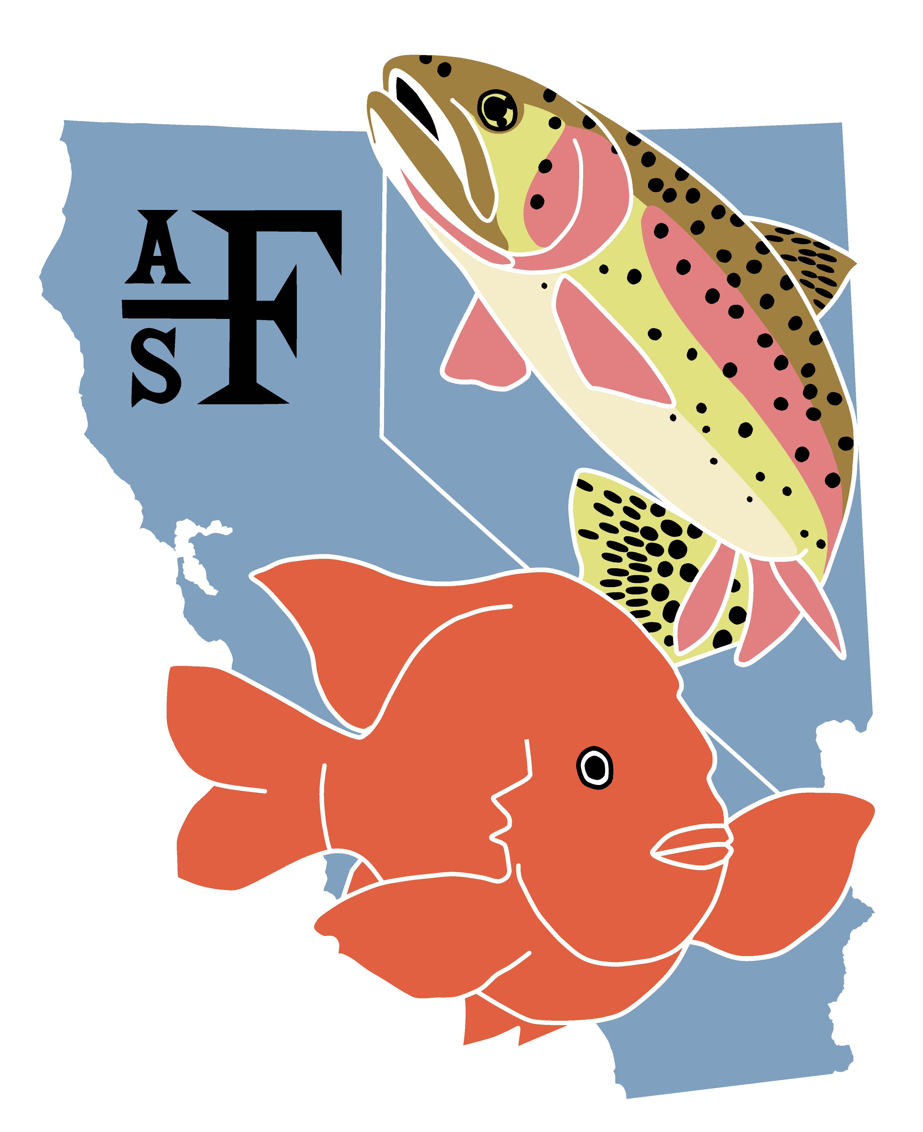
California-Nevada Chapter

President’s Plan of Work

Rob Titus, Cal-Neva Chapter President

October 2019 – September 2020

Presented at the Annual Mid-Year Chapter Retreat
Regional San/SASD, 10060 Goethe Rd., Sunset Maple Rm
Sacramento, CA 95827
January 26, 2020 (9:00 AM – 4:30 PM)

The purpose of this document is to outline priority activities in which I intend to engage during my term as President of the California-Nevada Chapter (Chapter) of the American Fisheries Society (Society). The intent of these activities is to further the goals of the Chapter per its Strategic Plan (working from the 2017 draft plan). Much of the work outlined here goes beyond conducting routine Chapter business and may, thus, represent more ambitious goals than can reasonably be achieved within a very modest 11-month mandate period. This may especially be the case given the volunteer nature of the work and competing demands with both professional and private life. In short, best intentions underly what may well play out to be a case of “aiming high but shooting low.” Hopefully, a worthy target or two will be hit, nonetheless.

Priority activities:

- Build membership through recruitment, retention, and reactivation
- Expand outreach activities
- Expand conservation activities
- Continue work of Past President(s)
I reference connections to the Chapter’s strategic plan, as appropriate, below.

- Build membership through recruitment, retention, and reactivation

The California-Nevada Chapter has progressively lost membership from the fishery management community. This sector is a major part of the fishery science profession yet is largely absent from the fisheries dialogue conducted in our chapter. Fishing and fishery management are major components of what keeps our profession relevant to society. The overall objective under this rubric is to re-engage the fishery management community in the Chapter. This objective is less about the numbers, per se, but more about the representation.

Target groups:
- State fishery biologists and managers, both inland and marine
- Hatchery managers
- Fishing industry related advocacy groups
- Students in conservation biology and environmental science

Specific actions proposed
- Use internal channels at California Department of Fish and Wildlife (CDFW), including its Science Institute, to reach CDFW fisheries and hatcheries scientists and managers for recruitment and reactivation, as applicable.
- Inform or remind prospective members of State reimbursement of annual membership fees, and conditions for CDFW support to attend annual chapter meetings.
- Contact chapter members with Nevada Department of Wildlife (NDOW) and explore opportunity to conduct similar internal outreach with prospective members employed as fishery professionals with NDOW.
- Develop symposia themes for Chapter annual meetings that explicitly involve various types of fisheries (inland, marine, sport, commercial, etc.).
- Conduct outreach and explore opportunities to recruit leaders in the fishing and guiding industries into the fisheries dialogue conducted through the Chapter and the Society. Example target groups are Nor-Cal Guides and Sportsmen’s Association, Golden State Salmon Association.
- Conduct outreach to stimulate further student subunit activity. Naturally, my first target is Sac State (see item 2 below), but also fledgling subunits at UNR, CalPoly, and Long Beach State.
- These actions are consistent with strategic plan item 5: Retain and increase membership through outreach and benefits.

- Expand outreach activities
Outreach is an essential aspect of what the Chapter does on a routine basis to keep membership alive and ideally growing. An obvious objective with outreach is to maintain a flow of new recruits into the Chapter by stimulating and supporting contact and activity at the student level. However, outreach is also important as a mechanism to work with the public directly on issues related to fisheries, aquatic habitats, and environmental quality in a broader sense.

Specific actions proposed
- In the spirit of the Native Fishes Committee for Chapter members, sponsor field sampling activities for college and university students in biological and environmental sciences to provide exposure, experience, and opportunity to learn about and engage with the Society. Esther Tracy and I have discussed targeting the Field Biology Group at Sac State to conduct fish and habitat survey work in the Dry Creek system (western Placer and Sacramento counties). This activity would hopefully serve to engage Sac State students in the Sacramento-Davis Subunit.
- Expand the Diversity and Outreach Committee to provide delegates throughout the California-Nevada footprint to represent the Chapter in local events and activities related to fisheries and aquatic habitats. Example activities are Creek Week and Earth Day (April 22, 2020) events, working with watershed conservancies and leading “salmon walks” on local streams, participating in World Fish Migration Day (May 16, 2020).
- Develop outreach materials that not only represent the Chapter and the Society, but also address specific types of issues (e.g., local creek protection), perhaps even regional specific.
- These actions touch on strategic plan items 4: Communication, 5: Membership through outreach, and 6: Networking.

- Expand scope of conservation activities
Conservation of fishery resources and the habitats upon which they depend is a major imperative of the Society. The Chapter does an excellent job of serving in its advocacy role toward this end by developing position letters on proposed legislation and actions that affect fisheries and aquatic habitats. A step further in this role may be to develop position papers on particular topics that are timely in fisheries within California-Nevada, and which may influence development of public policy, management agency decision making, and legislative action. An example topic is predatory fish control, which has far reaching implications in management of fisheries and aquatic systems.

Specific actions proposed
- Lead a discussion within the Chapter ExComm to explore the concept.
- If viable, determine if there is Society guidance or policy on subject.
- Once established, and if still viable, develop a Chapter process.
- Process would likely include vetting a topic, establishing an ad hoc sub-committee within the Conservation Committee to work on the position, conducting the research, and developing the position paper.
- Once completed, reviewed, revised, and approved by the ExComm, the position paper would be disseminated to the appropriate entities.
- These actions are consistent with strategic plan item 7: Promote the fisheries profession and support evidence-based decision making for the conservation,
- development, and wise use of fisheries resources and aquatic ecosystems.

- Continue on-going work of the Past President
- See work plan for Past-President Steve Brumbaugh from December 2018.

