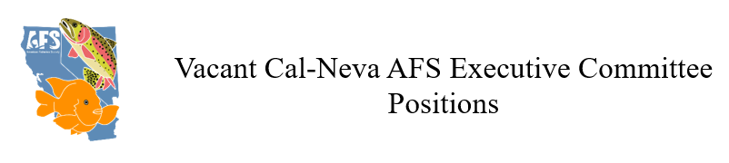
Each year, Cal-Neva AFS organizes exciting events and opportunities for fisheries professionals and students. We need your help with these activities! Let us know you’re interested here.

- Continuing Education Coordinator

The Continuing Education Coordinator shall determine the educational needs of chapter members and set up educational programs to fulfill such needs.

Benefits:
- Discounted registration for Cal-Neva AFS meetings
- Great networking opportunities with fellow fisheries professionals

Tasks:
- Attend monthly Executive Committee meetings
- Propose potential courses or workshops
- Contact potential instructors for courses or workshops
- Manage details for continuing education courses (e.g., instructor fees, presentation hardware, student access to computers)
- Serve on the Cal-Neva AFS meeting planning committee

- Diversity & Outreach Coordinator

The Diversity and Outreach Coordinator shall encourage and support professional interactions between Cal-Neva AFS members, AFS Western Division’s Diversity and Inclusion Committee, and the national AFS Equal Opportunity Section. The coordinator will work to increase the representation and involvement of diverse groups and will foster a welcoming, inclusive, and supportive environment for the professional development of underrepresented groups.

Benefits:
- Discounted registration for Cal-Neva AFS meetings
- Great networking opportunities with fellow fisheries professionals

Tasks:
- Attend monthly Cal-Neva AFS Executive Committee meetings
- Increase outreach, recruitment, engagement, and retention efforts with the goal of building and maintaining AFS membership
- Participate in the national AFS Equal Opportunities Section (EOS) and AFS Western Division’s Diversity and Inclusion Committee
- Develop and conduct an annual voluntary survey to determine demographics of our membership and track changes over time

- Time & Place Coordinator

The Time and Place Coordinator selects times, locations, and facilities to accommodate the Cal-Neva AFS meetings, under guidance of the elected Cal-Neva AFS officers. The locations for meetings shall be selected and presented to the Executive Committee at least nine months prior to the meeting.

Benefits:
- Discounted registration for Cal-Neva AFS meetings
- Great networking opportunities with fellow fisheries professionals

Tasks:
- Coordinate and plan the logistics of Cal-Neva AFS meetings
- Ensure that Cal-Neva AFS is compliant with the stipulations of venue contracts (e.g., contracts with hotels)
- Attend monthly Executive Committee meetings
- Serve on the meeting planning committee
- Arrange accommodations for any attendees needing special accommodations
- Recruit volunteer help
- Manage banquet orders for Cal-Neva AFS meetings

- Grants Coordinator

The Grants Coordinator administers all Cal-Neva AFS grants, including travel grants and the Small Projects Grant Program.

Benefits:
- Discounted registration for Cal-Neva AFS meetings
- Great networking opportunities with fellow fisheries professionals

Tasks:
- Develop grant solicitations and guidelines for travel grants and the Small Projects Grant Program
- Develop a scoring matrix to evaluate applications
- Notify all awardees of the travel grants and Small Project Grants, with further instruction on their obligations according to the guidelines of the grant (e.g., presenting at an upcoming Cal-Neva AFS meeting)
- Notify unsuccessful applicants that they did not receive funding, with rationale provided during the evaluation process

